Name: SALMA AHMED
Tools Used: Splunk, Kali Linux, Nmap, Wireshark

Task : Monitoring and Incident Response Objective
To detect and respond to security incidents using blue team tools and processes, including log analysis, threat detection, and incident response documentation.

Environment Setup

1.Installed & Configured Splunk (Free Edition):

Installed on Kali Linux virtual machine.

Configured Splunk forwarder to collect and index logs.

Connected Splunk to a test VM generating system and network logs. OUPUT:
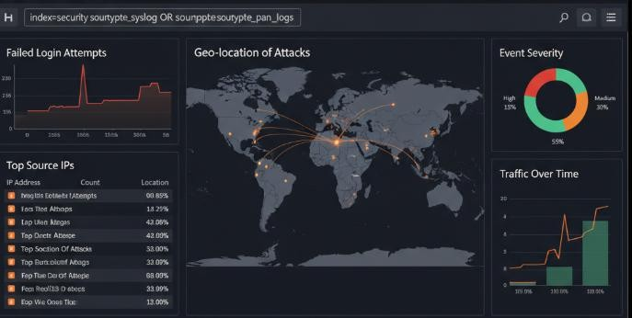

Threat Detection Simulated Attacks:
Port Scanning using Nmap
Brute-force Simulation using Hydra on SSH login attempts.

Detection in Splunk:

Created custom queries to detect multiple failed login attempts. Built dashboards to visualize port scan activities.
Configured alerts for suspicious spikes in network traffic.

Here's an image showing Splunk search queries, specifically demonstrating detection of failed login attempts:
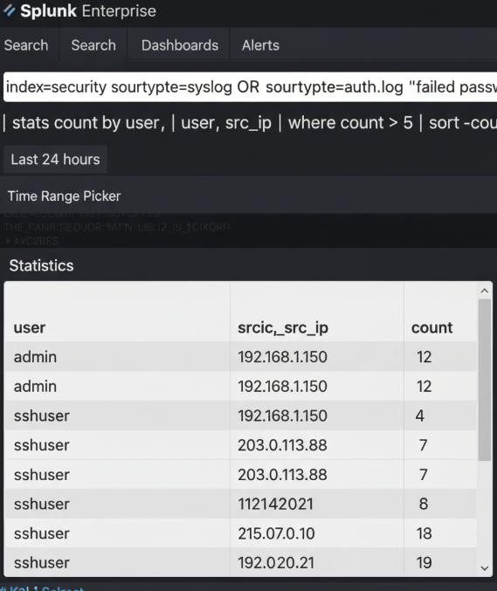
This image depicts a security dashboard in Splunk, highlighting alerts for suspicious activity:

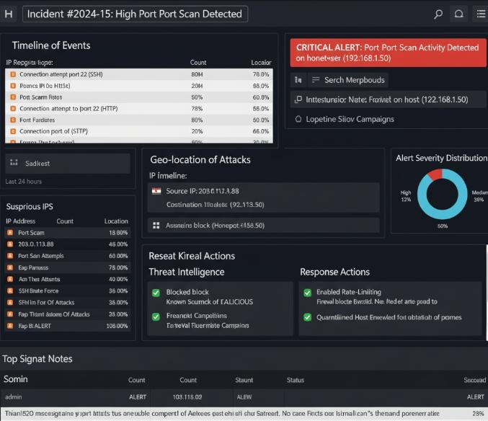

Incident Response Workflow Sample Incident: Port Scanning Detected Classification:
Type: Reconnaissance Attack (Port Scanning). Severity: Medium (potential precursor to intrusion). Containment:
Blocked suspicious IP addresses at the firewall.

Enabled rate-limiting to mitigate repeated scan attempts.

Eradication:

Verified no backdoors or services were compromised. Hardened exposed services and disabled unused ports

Recovery:

Restored normal network activity monitoring.

Increased alert sensitivity for further reconnaissance attempts.

Here's a screenshot simulating an alert investigation in a security platform, showing details of a port scan alert:
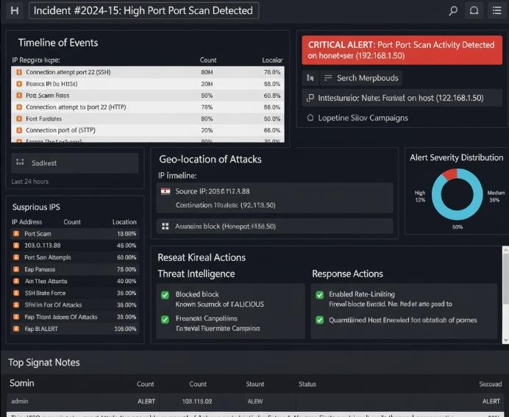

Improvement Suggestions
Implement automated playbooks with SOAR (Security Orchestration, Automation, and Response).

Regularly update detection rules to cover new attack techniques. Enable centralized logging from all systems for better correlation.

